Create a parameterized job in Jenkins.
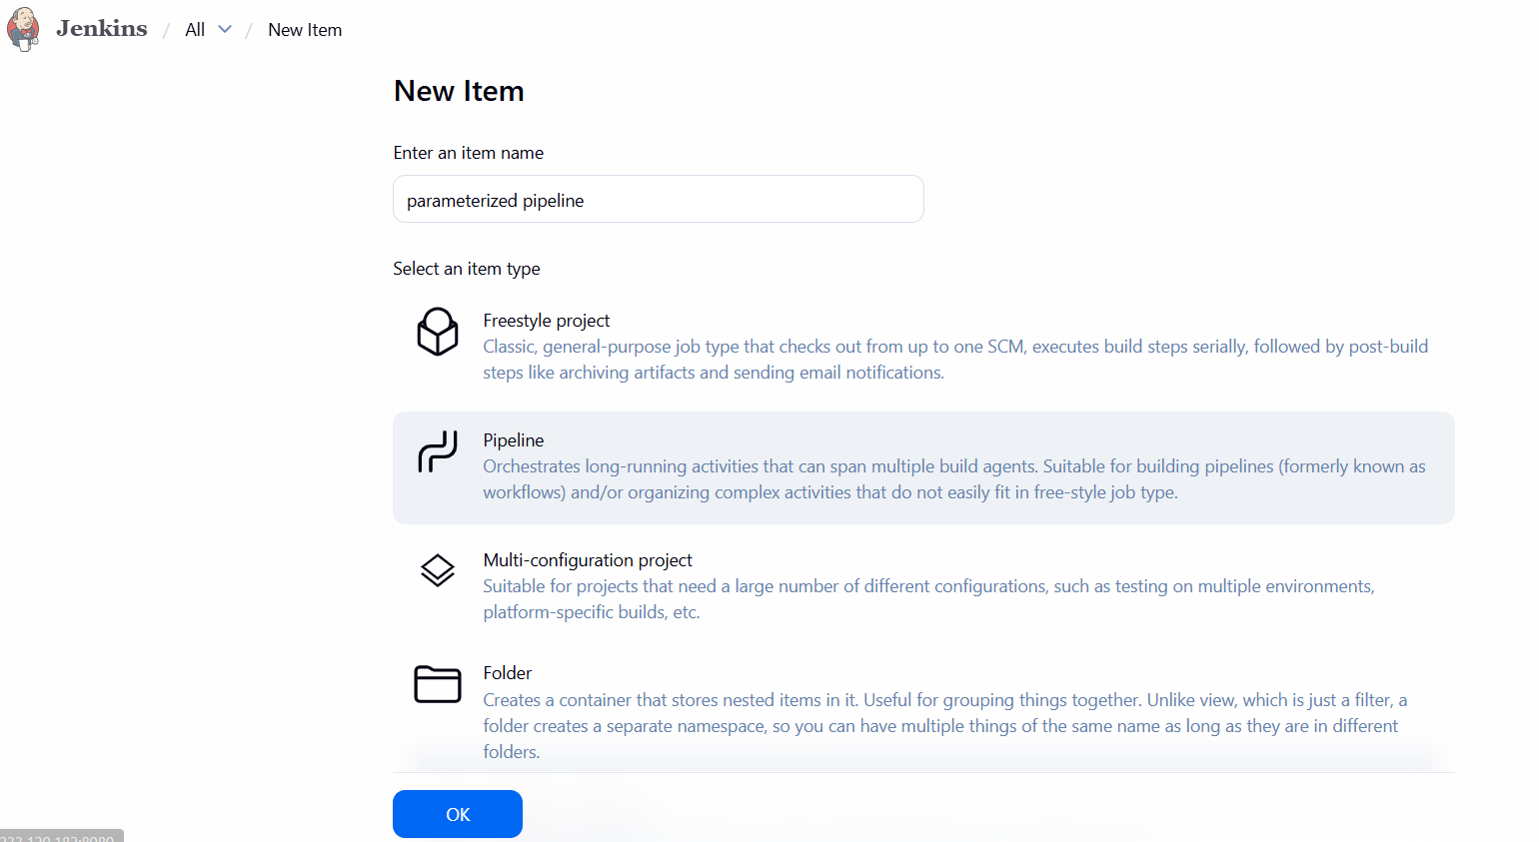
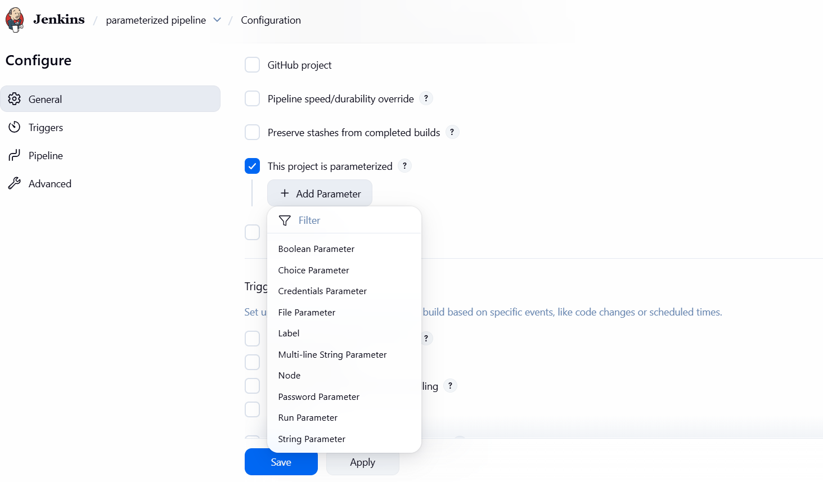
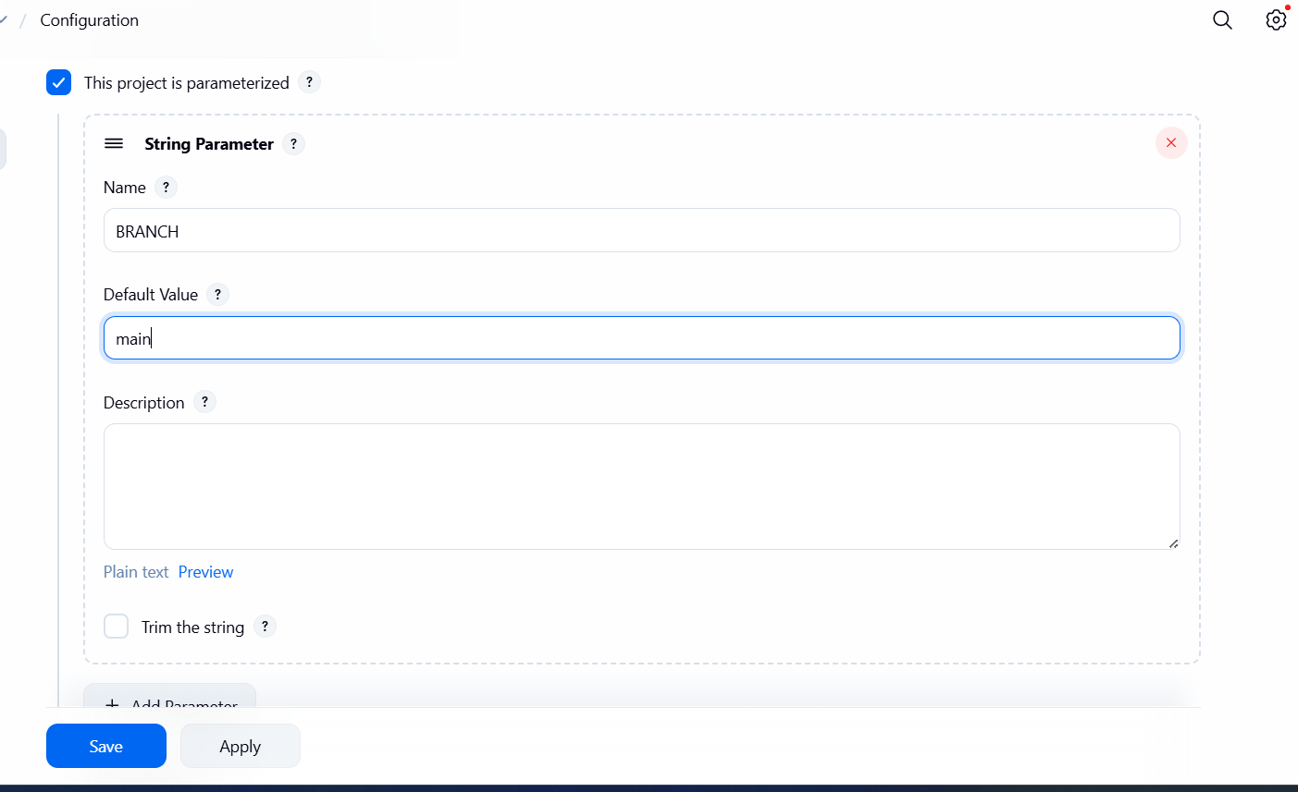
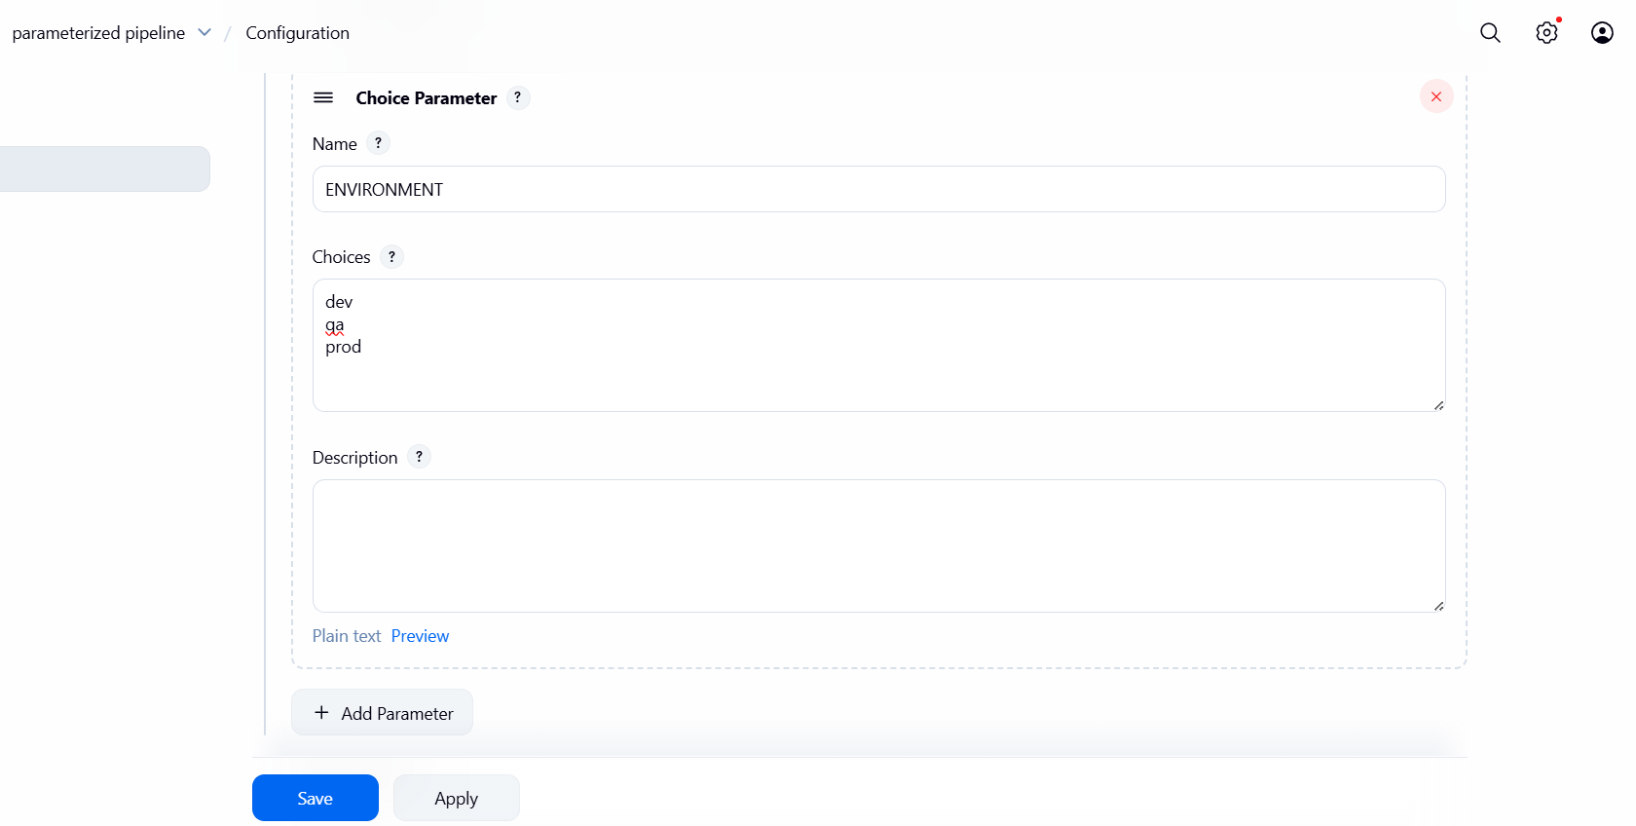
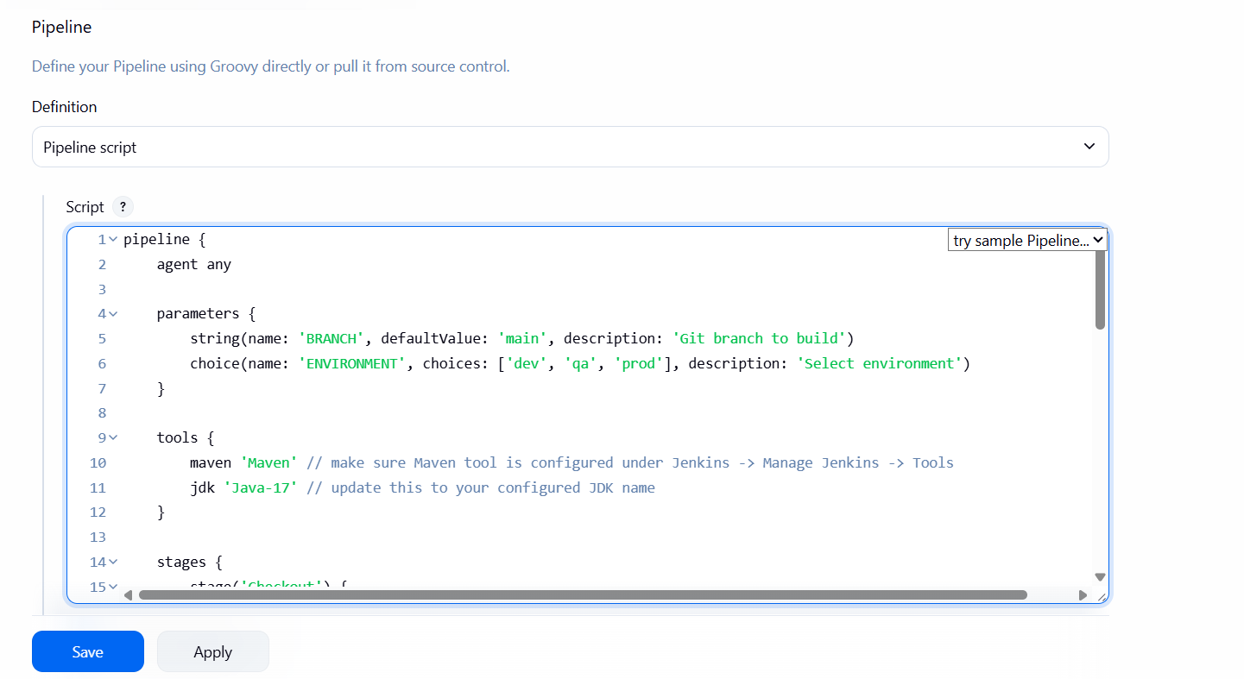
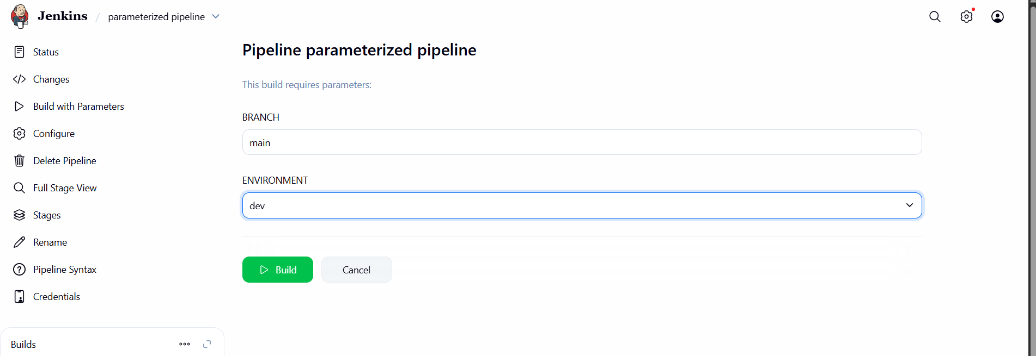
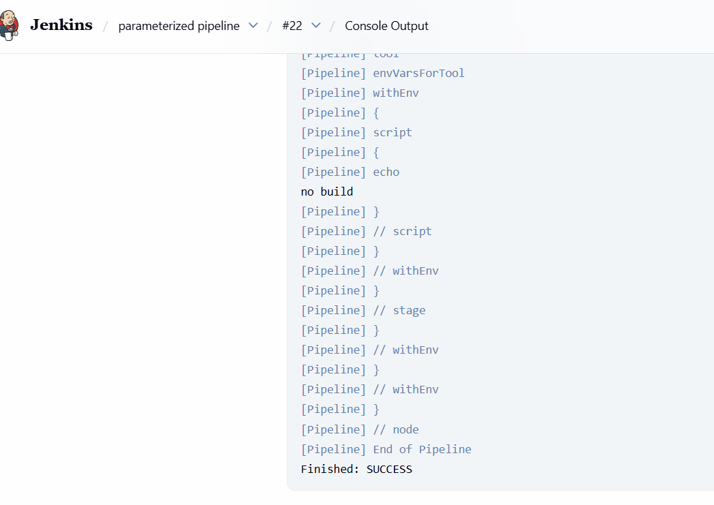
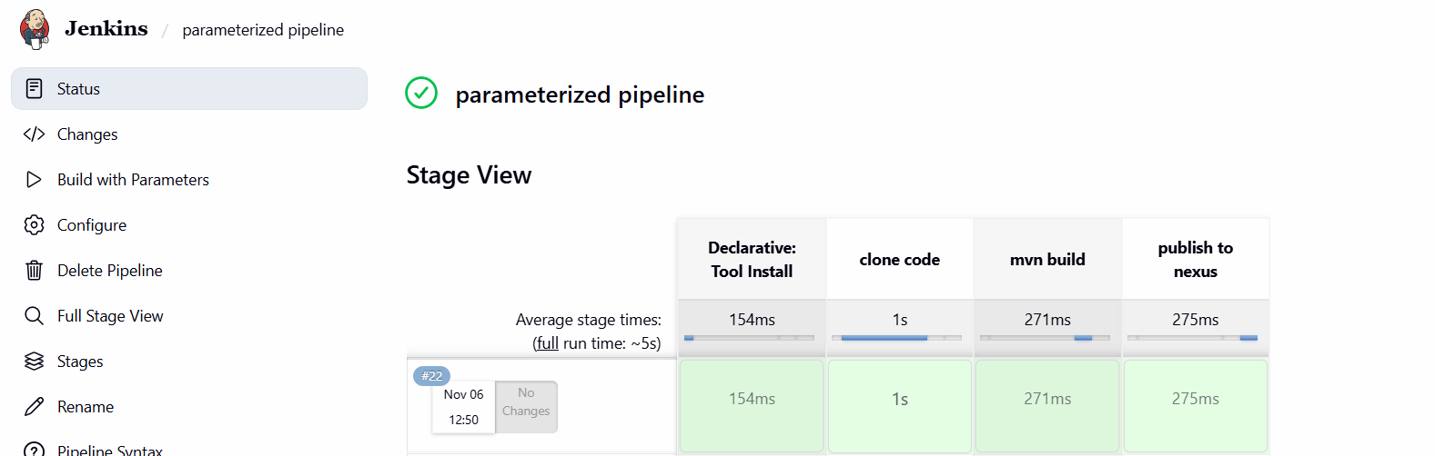
pipeline {

agent any

parameters {
gitParameter branchFilter: 'origin/(.*)', defaultValue: 'origin/master', name: 'BRANCH', type: 'PT_BRANCH'

booleanParam(defaultValue: false, description: '', name: 'mvn_build')
booleanParam(defaultValue: false, description: '', name: 'publish_to_nexus')

}
tools {
// Note: this should match with the tool name configured in your jenkins instance (JENKINS_URL/configureTools/)
maven "Maven"

}
environment {
// This can be nexus3 or nexus2
NEXUS_VERSION = "nexus3"
// This can be http or https
NEXUS_PROTOCOL = "http"
// Where your Nexus is running
NEXUS_URL = "13.233.66.167:8081/"
// Repository where we will upload the artifact
NEXUS_REPOSITORY = "ncodeit-helloworld"
// Jenkins credential id to authenticate to Nexus OSS
NEXUS_CREDENTIAL_ID = "nexus_credentials"
}
stages {
stage("clone code") {
steps {
script {

// Let's clone the source
git branch: "${params.BRANCH}", url: 'https://github.com/saivarun0509/spring3-mvc-maven-xml-hello-world-1.git';

}
}
}
stage("mvn build") {
steps {
script {
if (params.mvn_build) {
// If you are using Windows then you should use "bat" step
// Since unit testing is out of the scope we skip them
sh '/usr/share/maven/bin/mvn -Dmaven.test.failure.ignore clean package'
} else {
echo "no build"
}
}
}
}
stage("publish to nexus") {
steps {
script {
if (params.publish_to_nexus) {
// Read POM xml file using 'readMavenPom' step , this step 'readMavenPom' is included in: https://plugins.jenkins.io/pipeline-utility-steps
pom = readMavenPom file: "pom.xml";
// Find built artifact under target folder
filesByGlob = findFiles(glob: "target/*.${pom.packaging}");
// Print some info from the artifact found
echo "${filesByGlob[0].name} ${filesByGlob[0].path} ${filesByGlob[0].directory} ${filesByGlob[0].length} ${filesByGlob[0].lastModified}"
// Extract the path from the File found
artifactPath = filesByGlob[0].path;
// Assign to a boolean response verifying If the artifact name exists
artifactExists = fileExists artifactPath;
if(artifactExists) {
echo "*** File: ${artifactPath}, group: ${pom.groupId}, packaging: ${pom.packaging}, version ${pom.version}";
nexusArtifactUploader(
nexusVersion: NEXUS_VERSION,
protocol: NEXUS_PROTOCOL,
nexusUrl: NEXUS_URL,
groupId: pom.groupId,
version: '${BUILD_NUMBER}',
repository: NEXUS_REPOSITORY,
credentialsId: NEXUS_CREDENTIAL_ID,
artifacts: [
// Artifact generated such as .jar, .ear and .war files.
[artifactId: pom.artifactId,
classifier: '',
file: artifactPath,
type: pom.packaging],
// Lets upload the pom.xml file for additional information for Transitive dependencies
[artifactId: pom.artifactId,
classifier: '',
file: "pom.xml",
type: "pom"]
]
);
} else {
error "*** File: ${artifactPath}, could not be found";
}
} else {
echo "no build"
}
}
}
}
}
}

